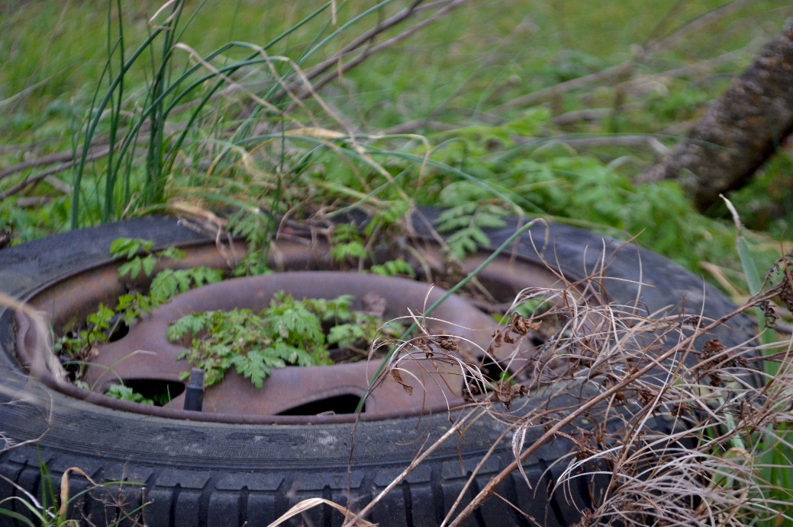Initial Shoot

I think that this is one of the least successful out of the initial shoot, because of the over-powering green, as it was hard to subtle it on photoshop, as well as adjusting the tones in black and white. It was difficult to find the right tones, to make it stand out.

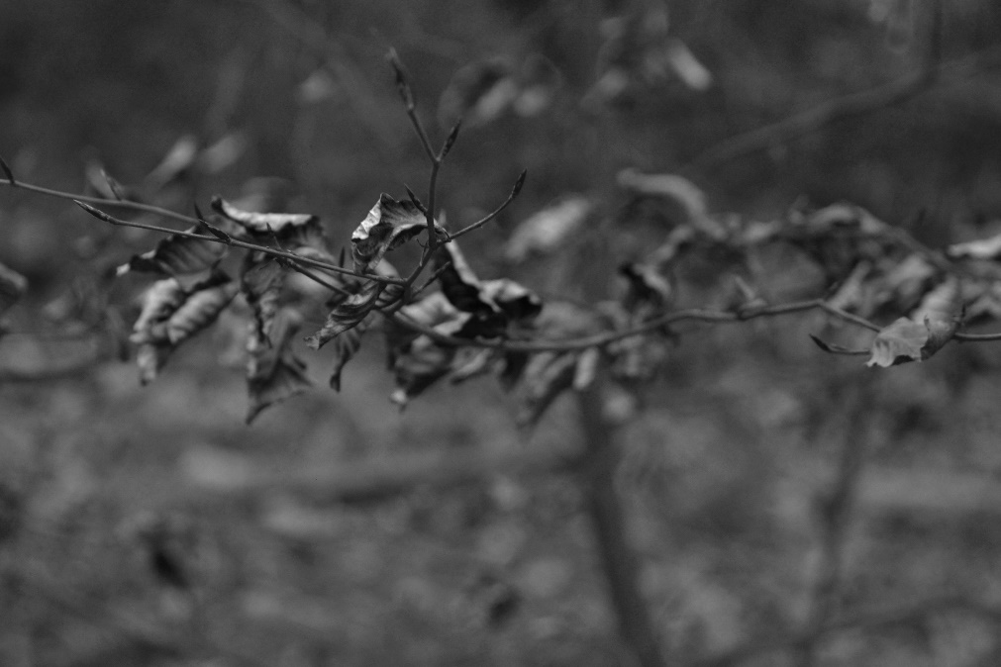

This one of the initial shoots successes, as the depth of field makes it aesthetically pleasing, as well as the black and white tones, thank gives the photograph a very emotive feel.

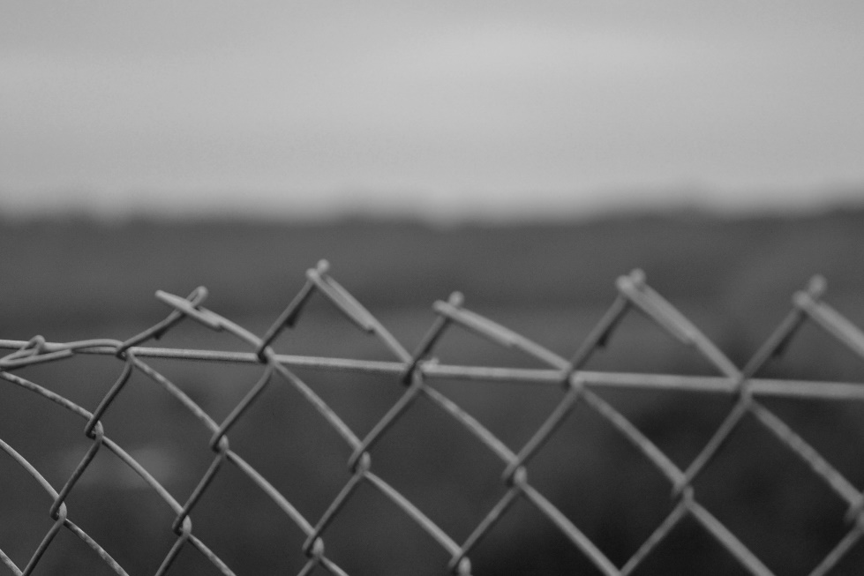This is one of my personal favourite successes, because the black and white tones work well with the features in the photograph. Also the depth of field between the fence and the forest and fields in the background really make each other stand out, as well as the depth of field towards the front of the fence as it becomes more focused the further away it gets.

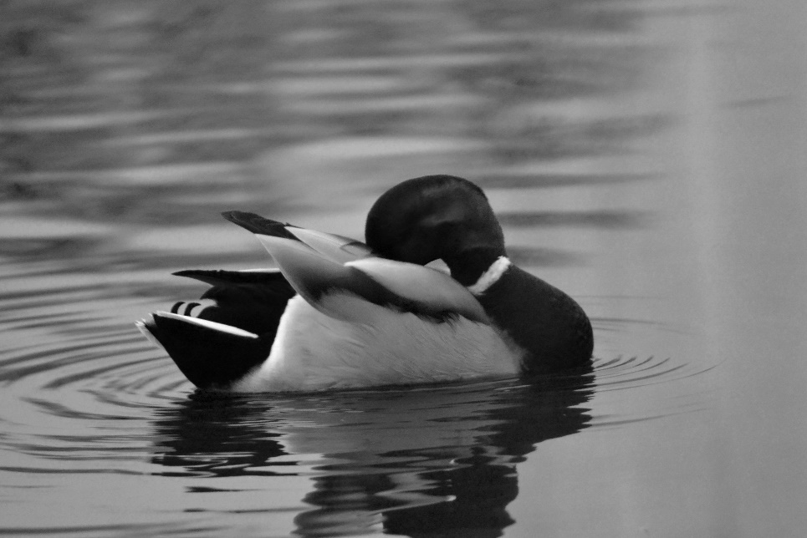This is another success from the initial shoot, as the adjusted tones work well in black and white. This was also an experimented piece into animals, rather than nature.