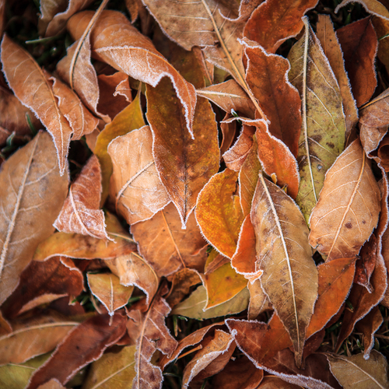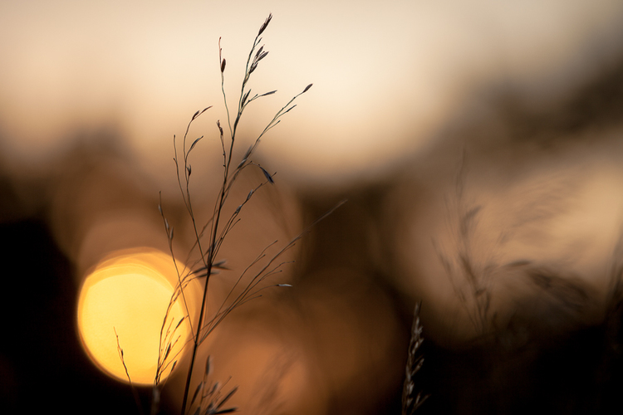**Valerie Jardin**

This is from Jardin’s portfolio ‘Landscape and Nature’. Her work inspired me to use depth of field and close ups on nature. She also has a variety of different genres of photography in her portfolios and projects. I was also inspired by her street and contemporary work in her other projects and portfolios.

**Rui Palha**

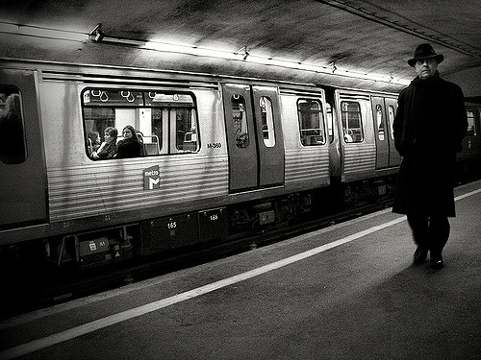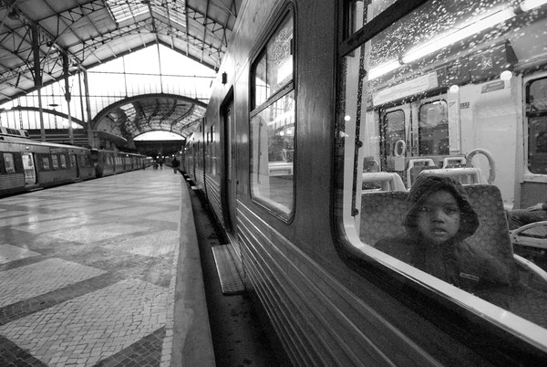

This is from Palha’s portfolio ‘Underground’. This inspired me for the street genre, and the black and white contemporary theme. His other work in his portfolios are all in black and white, which also inspired me to keep the theme of black and white throughout my series.

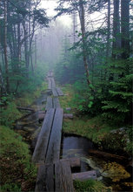**Patrick Zephyr**

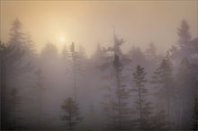

This is from Zephyr’s gallery ‘Forests and Trees’. This inspired me to incorporate nature in my series, as well as using more depth. His other galleries, such as ‘Black and white’, ‘A closer look’ and ‘Magic hour’, also inspired me to incorporate aspects into my work.

**Chuck Jines**

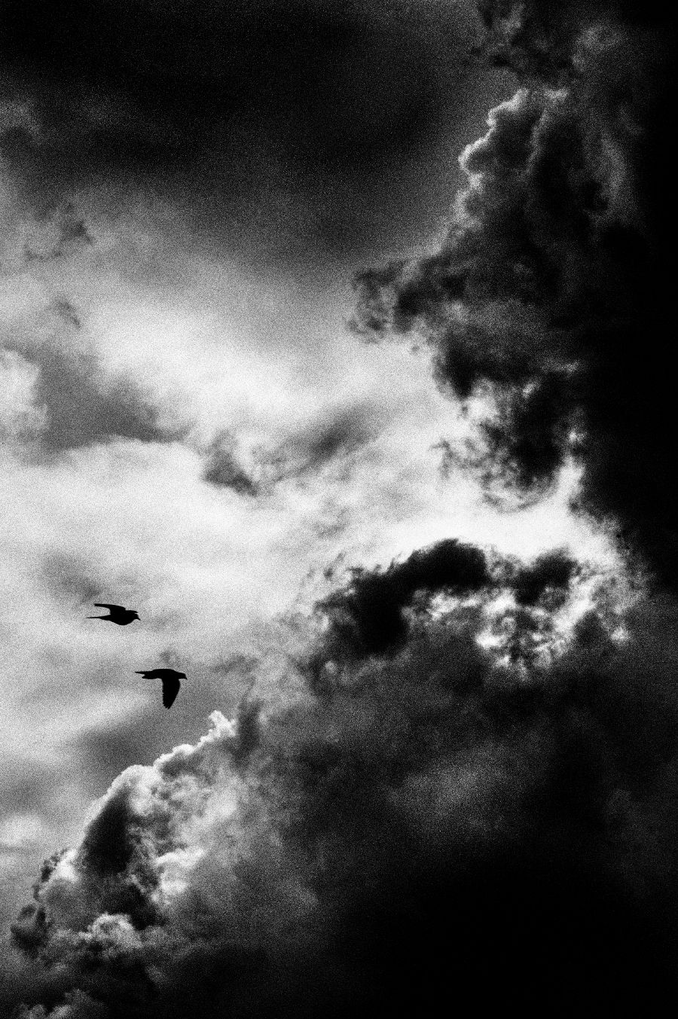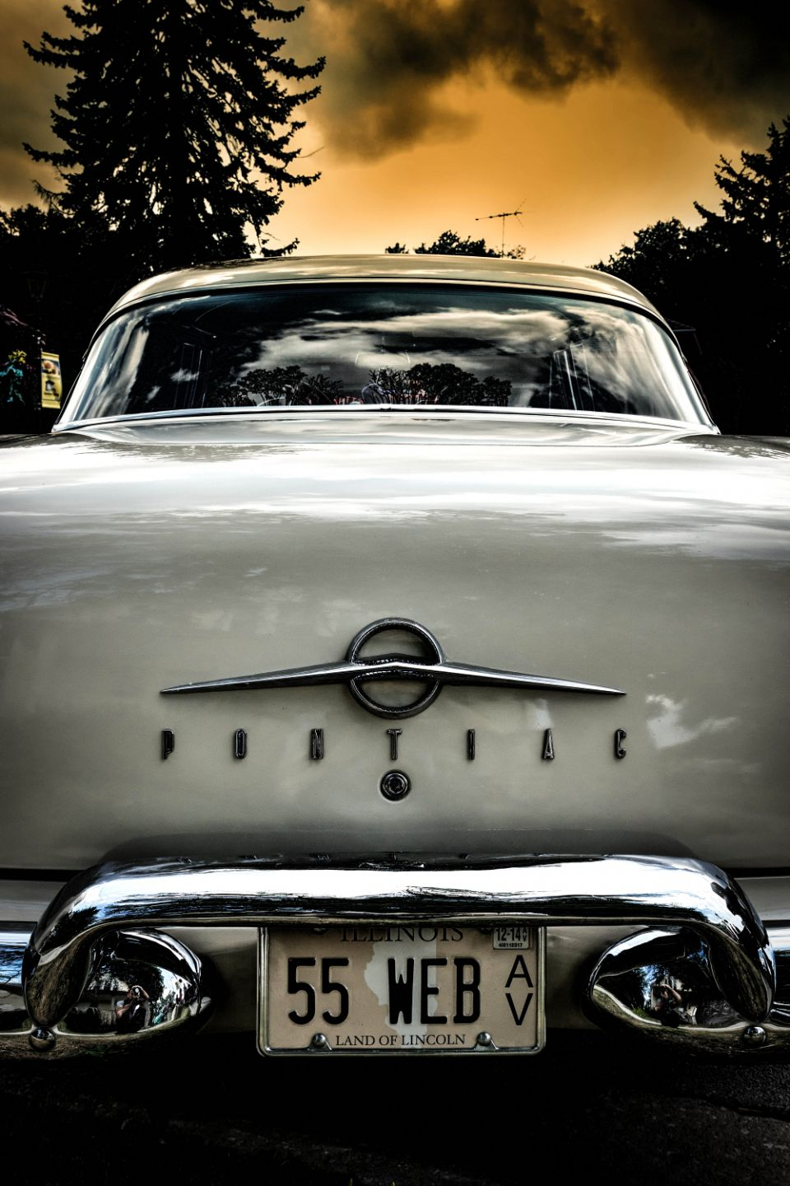

This is from Jines’ ‘Automotive’ and ‘Urban Nature’, his work inspired me to include retro/vintage aspects as well as using contrasting colours and tones that make each other stand out.