Poster Analysis

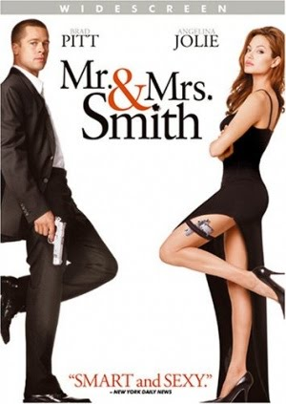

The poster is very minimalistic as it just has a plain white background, making Brad Pitt and Angelina Jolie stand out more, as they are both wearing black clothing. The colour white usually has a positive connotation, of innocents, purity, safety etc. while on the other hand black symbolises evil, death and mystery. As the white is in the background this would suggest that everything that was good is in the past, and now there is some sort of war between the characters which is represented through the colour of their clothes. This is also shown because they are on opposite sides of the poster, emphasising that there is a distance between them. The colour black is also associated with power and elegance, this could link in with their jobs, as they are both dresses smartly and have a weapon as well as their pose showing that they are confident in knowing what they are doing and are good at it. In the title, there is a bullet hole that has dotted the ‘I’ in ‘Smith’, this shows that there is violence/action in this movie and it involves them. The ‘&’ is in red, which immediately draws your eye to it as it is in a bright colour against a plain minimalistic surrounding. Red symbolises danger and blood, meaning that having Mr. Smith and Mrs. Smith together is dangerous. It also symbolises love, which also shows that they love each other.

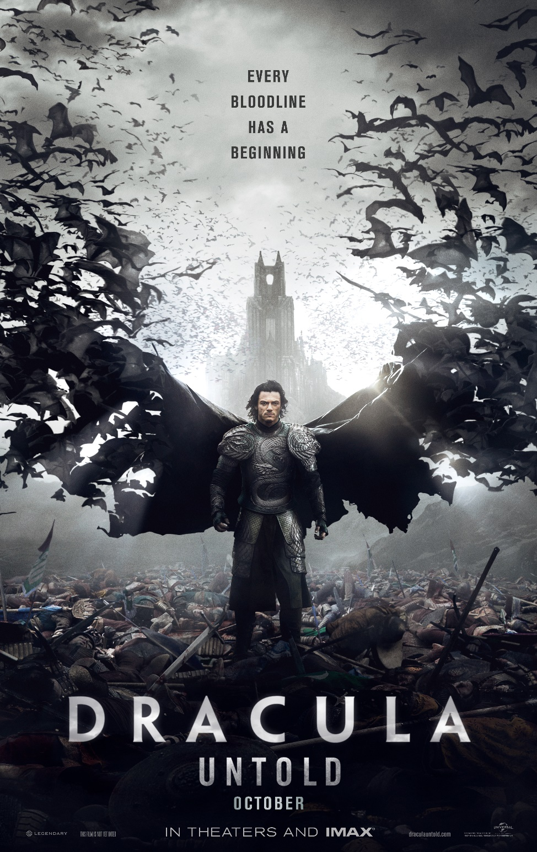

This poster has black as its dominant colour, implying that this film is filled with death, evil and mystery. Luke Evans is central in the poster, which, as well as showing he is the main character, he is powerful and intimidating. Behind him, there is a battlefield full completely of dead warriors; and with Luke Evans as the only one left standing, this implies that he fought and killed them all, enforcing his power. His cape morphs into bats, and also makes it look like he has bat wings. Bats are often related to vampires, as they are both ‘creature of the night’, and there are a variety of different stories, some suggesting that vampires can transform into bats; which is what his cape implies. The castle in the background is also dark and mysterious, and there are two points at the very top, which look like vampire teeth. There is a light in the background, behind the castle, which connotes that there is hope in the end, once he gets past what he is. The title is bold, it has a mental-look effect to it connoting he is strong and hard to brake.

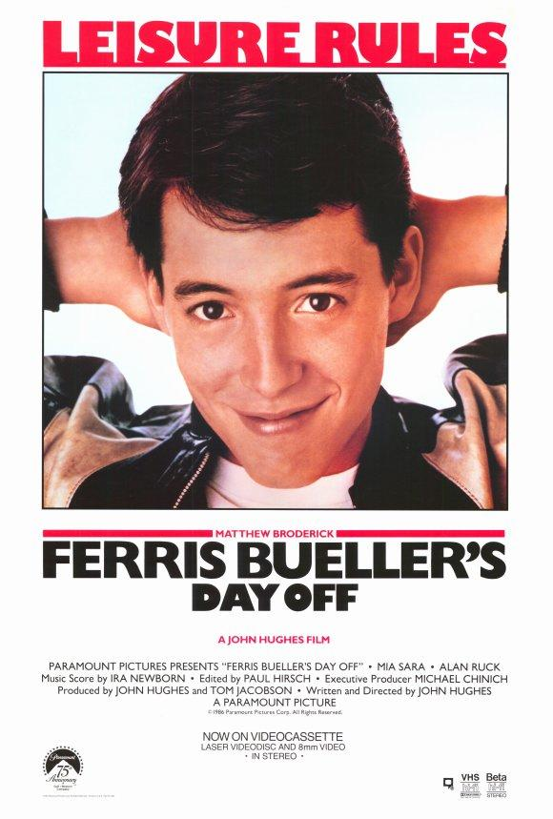

In this poster Mathew Broderick’s face is the only imagery, keeping the focus on him. He has his hands behind his head, showing he is relaxed. He also has a smug smile and overall look, showing that he is proud of his himself and his achievements, giving an adventurous/playful feel to the movie already. The slogan, ‘Leisure Rules’, is in bright red, symbolising passion, desire, courage, danger, action and determination. Which all represents Ferris and how he feels about living an exiting, fulfilling life.