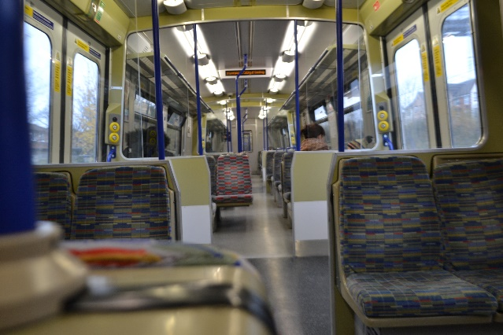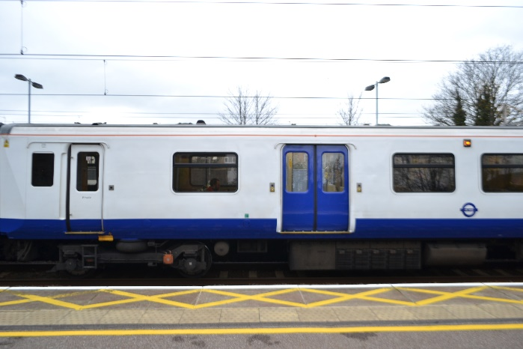I think that this picture was one of the failures of the shoot, because it doesn’t really fit into any of the six points of composition, therefore not making it as aesthetically pleasing. I do however like the camera angle, as it is a long shot; getting one carriage of the train in the frame.

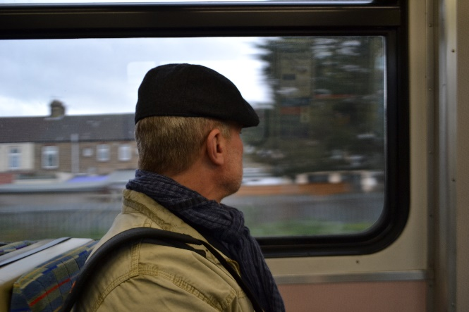I like this picture, because of the depth of field, where the corner of the chair is out of focus in the bottom left corner of the frame and everything beyond that is in focus. I also like the camera angle as it sits in line with the tops of the seats, as well as it having leading lines of the seats which we can see until the end of the carriage.

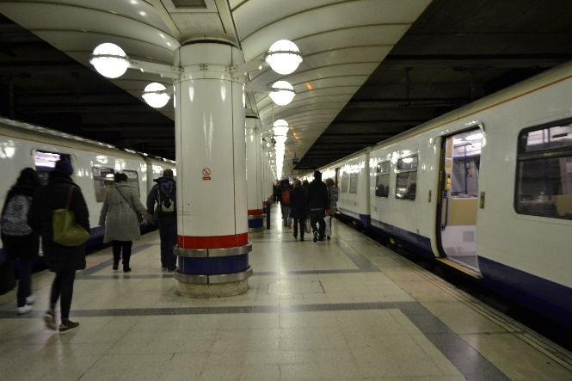I also like this picture because of the depth of field; everything in the train is in focus, outside is not. I also like how the person in this is framed by the window, and that they are not directly central to the picture, they are a little bit off to the left, making the image feel gentler. And because the background is out of focus it doesn’t divert the attention too much.

I think this photo was a success because of the leading lines that the pillars and trains give, as well as them being in the rule of thirds.

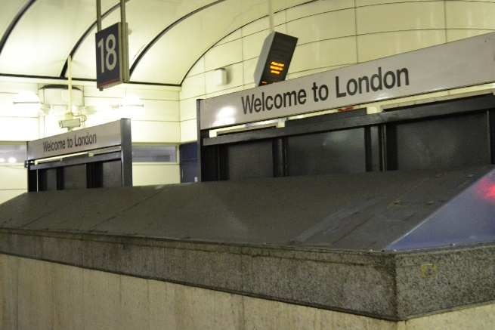

I like the angle of this photo as well as the depth of field, however there are other thing going on in the picture which makes it a little distracting from the sign.

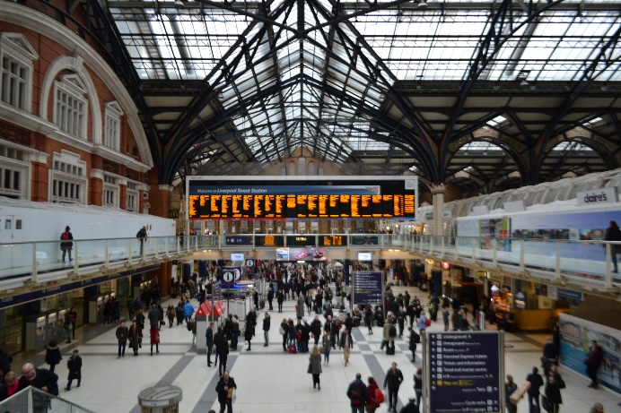I think that this picture was a great success in the shoot, because of the variety of leading lines, and the way theses sort of frame it. I also like the viewpoint of the photograph because it is not from the ground floor, therefore it is a high angle because you still have a view of looking down as well as it being level and a low angle.

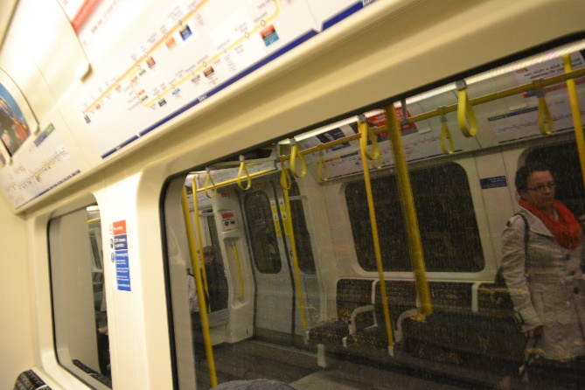

I like this shot because it has a depth of field; the reflection in the window is in focus, and it has leading lines.

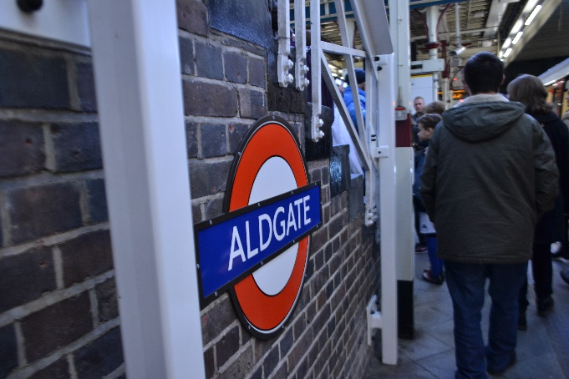

I think that the depth of field for this photograph was a success, as everything after the pole is in focus, and because of the bright colours of the sign, nothing else distract the attention from this.

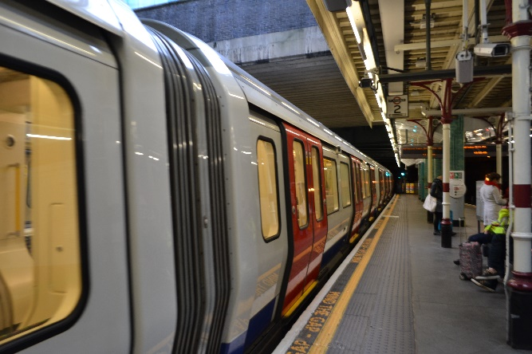I like the leading-lines in this photo; the train and the platform, because it’s from a point-of-view angle, which emphasises the length more.

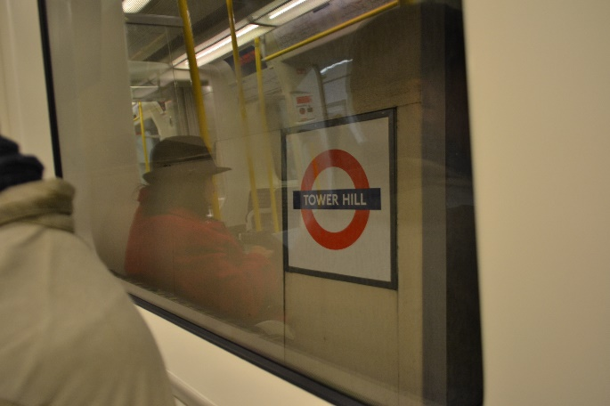

I think that angle of this shot was one of the failures, because the reflection takes the attention away from the sign, and would have looked better if the window framed it. I do, however like that this applies to the rule of thirds.

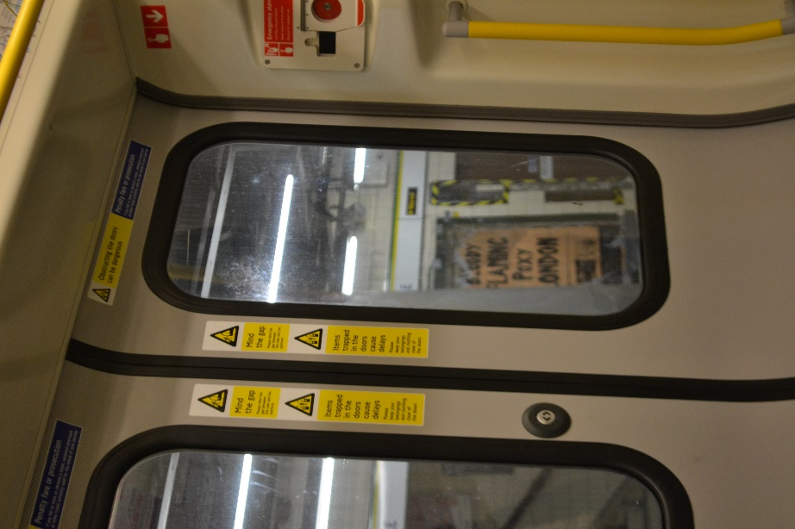I liked the depth of field on this photograph, where outside the widow are out of focus, however, my intensions were to get what was outside in-focus, which was the poster, that read; “Bloody, Flaming, Poxy London”. But, because the background of this picture is distracting, you can still notice the poster. I also like how the window in the door frames the poster, emphasising it that much more. I like the angle on this photograph, because it places the poster in the centre, making it seem more important.

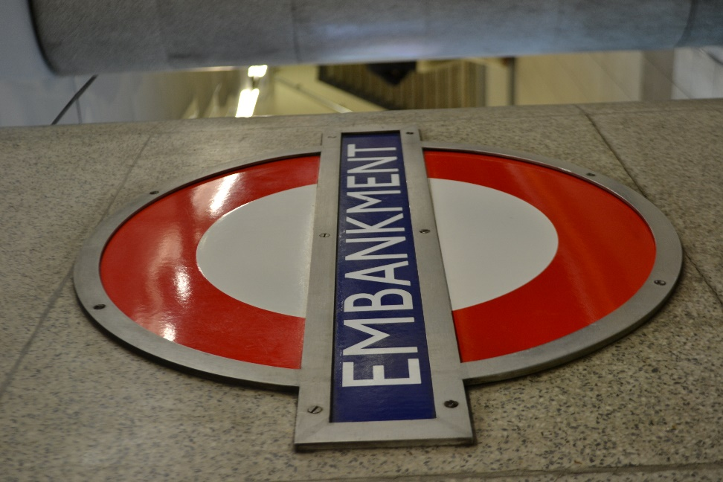

This photo was a success because of the depth of field where only the sign is in-focus. Also because of the bright colours of the sign against the dull, plain background makes it stand-out more. I like the angle of this, because of the effect of leading-lines it has on the sign.