**Video Production – Documentary**

**Production File**

Contents:

1. A diagram/list/mind map of all the original ideas for the documentary.
2. Synopsis.
3. Treatment.
4. Research.
5. Production Schedule.
6. My Role.
7. Location Recce.
8. Crew.
9. Interviewees.
10. Equipment List.
11. Health and Safety.
12. Script/Voice over.
13. Story board/Shot list.
14. Shoot Diary.
15. Project Evaluation.

**Original Documentary Ideas**

* Advertisement and Reputation.
* Prejudice and Discrimination.
* Homelessness (food bank).
* 5p bag charge.
* Football.
* Social media.
* Uni life.
* Music.
* Impact of Westfield compared to Lakeside.
* Gaming.
* Fears and phobias.
* NHS.
* Journey of getting a car/insurance.
* **Piercings and Tattoos, regarding work.**
* Life of a teenager.
* Younger generation/addiction to technology.
* Ethnic diversity within bars and pubs.

**Synopsis**

Tattoos and jobs. The public’s views and personal experiences.

**Treatment**

Visiting tattoo parlours, getting footage of the interior and interviews with the tattooists. Interviewing the public with and without tattoos, to get their opinions on them and people with them. Pans of peoples tattoos with voice overs.

**Research**

Tattoos have become more common over the past couple of decades. A poll in 2012 found that 1 out of every 5 adults – 21% - has at least 1 tattoo. An earlier pew research centre study found that the number was closer to 40% among those aged 18 – 29.

76% of employees feel tattoos and piercings hurt your job interview chances.

However, 73% of people say they would hire staff that had visible tattoos.

6% of tattooed people say they wouldn’t hire someone with visible ink.

Only 4% of tattooed or pierced people say they've actually faced discrimination in their current job.

**Production Schedule**

Team meeting at college on 19/02/16, for an hour. – Researched tattoo parlours in the area; Romford and Hornchurch. – Called the parlours to get permission to film there. – Watched documentaries on the subject. – Set up questions to ask the public and the tattooists.

Wednesday 2nd March, college. – Interviews Nikki, and took pan shots of her tattoos.

Tuesday 8th March, 10:30am. – Filmed the public’s comments at Romford Station.

Wednesday 9th March, college. – Interviewed students with tattoos and took panning shots of students and tattoos.

Friday 11th March. – Visit another tattoo parlour. – Interview more students from college. – Film any other shots that may be needed.

Monday 14th March, college. – Edit

Tuesday 15th March, college. – Edit. – shoot at a tattoo parlour.

Wednesday 16th March, college. – Edit.

Friday 18th March, college. – complete editing and hand in.

**My Role**

Co-cameraman, I set up the camera and tripod for the interviews, including the position and placements; what should be in frame.

Co-director, decided how the documentary should be presented and what to include.

Co-editor, how to sequence the shots, when to do the voice overs, how to present the questions.

**Location Recce**

Romford station - Romford is a large town in east London, United Kingdom, and the administrative centre of the London Borough of Havering. - Romford railway station is an interchange station on the Great Eastern Main Line, serving the town of Romford in the London Borough of Havering, east London.

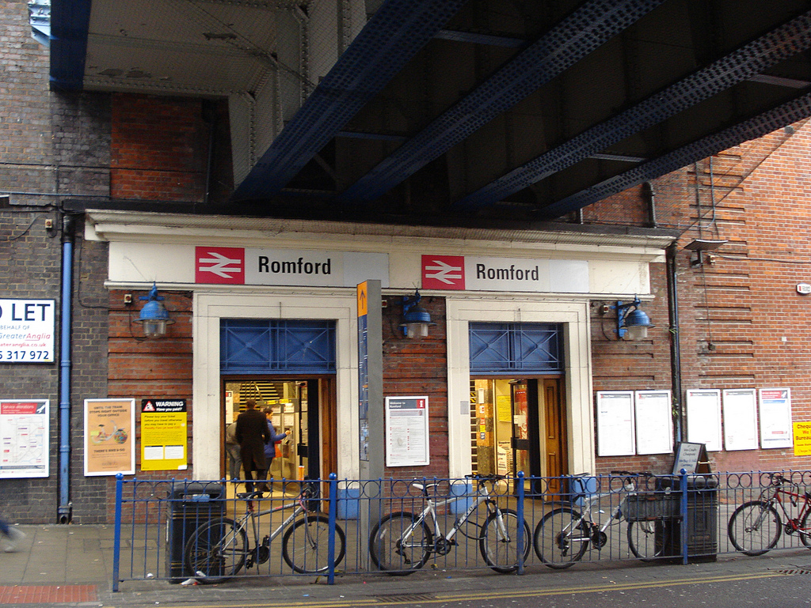

Hornchurch Town Centre - Hornchurch town centre is one of four major district town centres within the London Borough of Havering. Located in the centre of the Borough, approximately 4km to the south-east of Romford.​

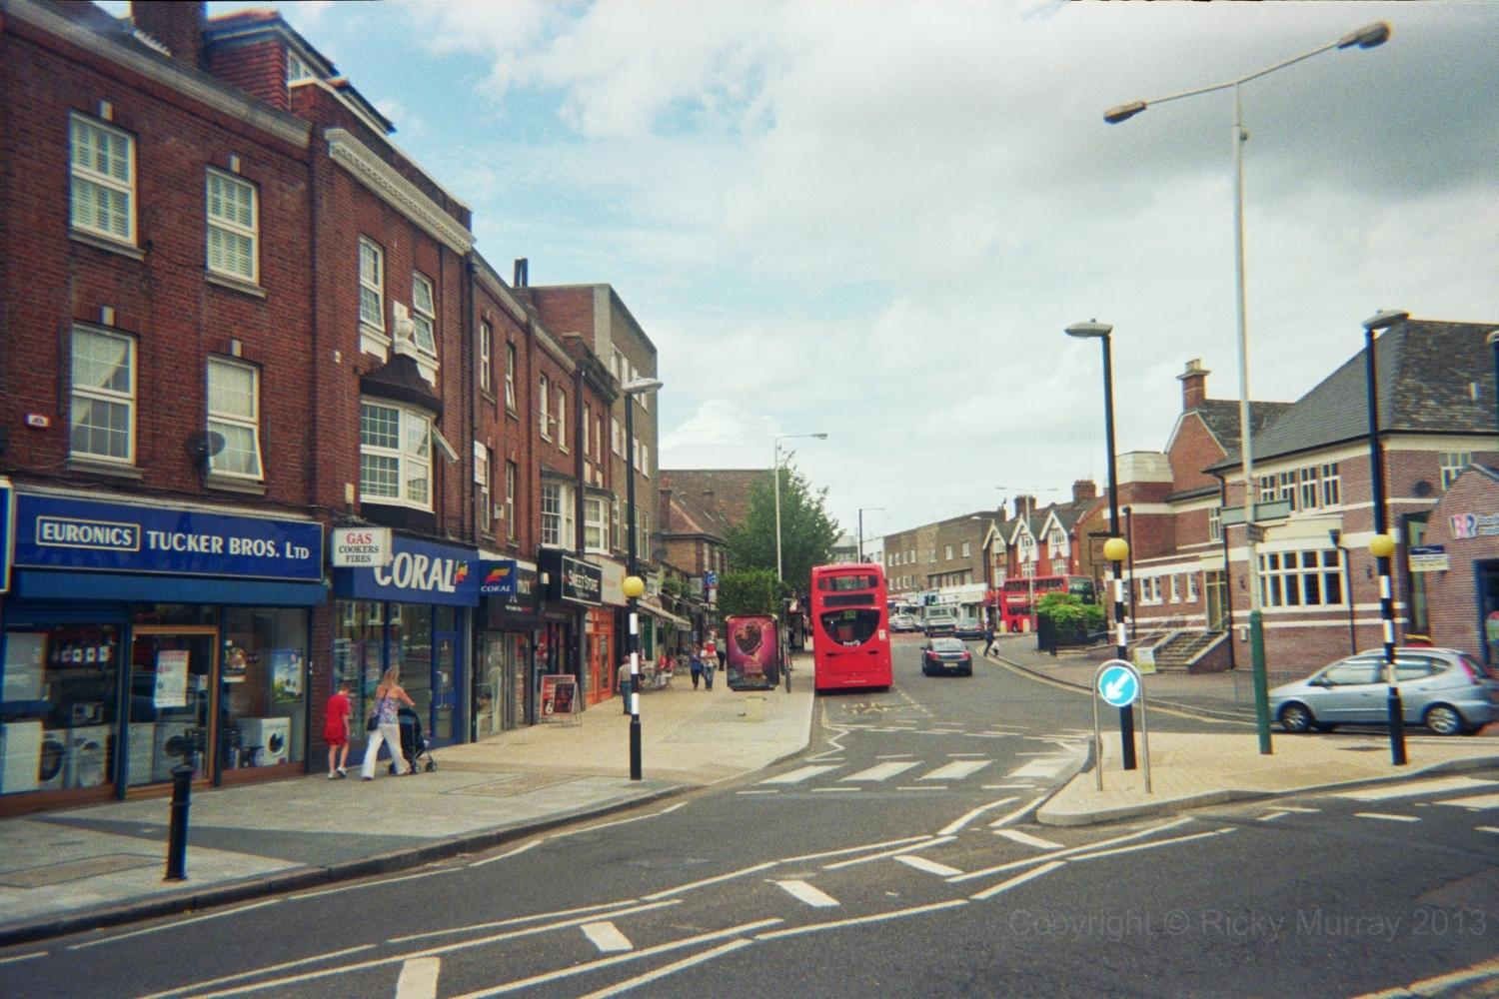

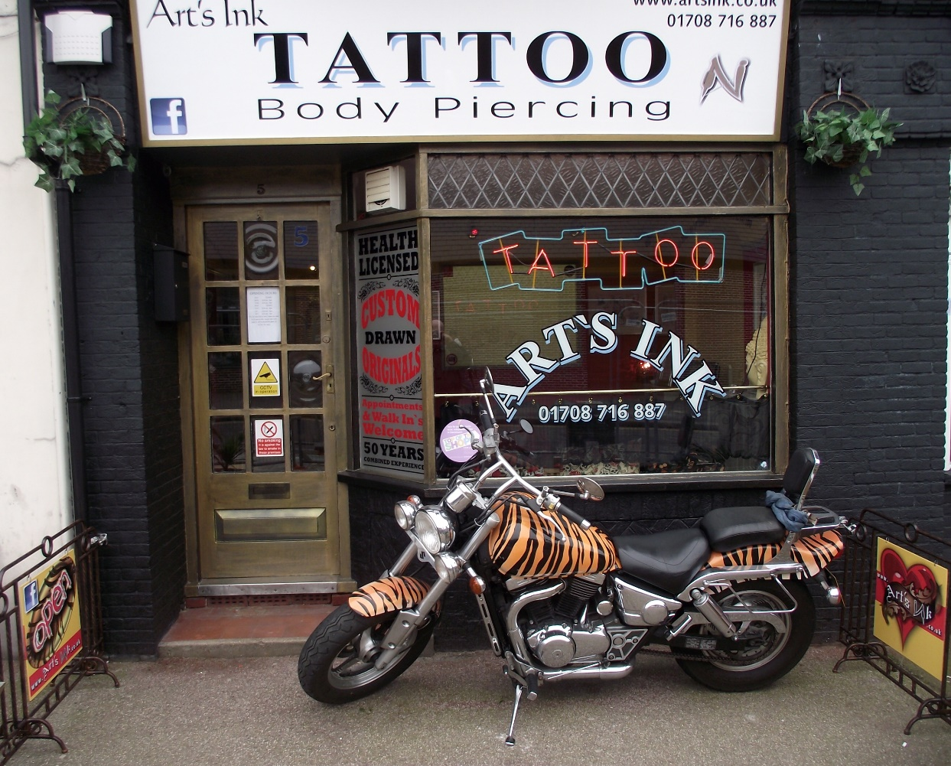

**Crew**

**–** Rhys – Lucy – Derrick

Everyone shared the roles, allowing each to contribute something from being a cameraman, an editor and a director.

**Interviewees**

The people being interviewed were the public expressing their own opinions. There is also a voice over.

**Equipment List**

Final Cut Pro

Card based camera

XLR leads

Boom mike

Tripod

**Health and Safety**

People in the shots: we will need to get permission from them to say that they agree to being filmed, and avoid any of the public passing by.

Equipment: possibility of the camera etc. getting stolen, dropped/broken, the weather conditions such as rain could damage it. Wires: people may trip over any if they are left around or loose.

Electric shock: Check condition of plugs and. You should not be able to see the inside insulation. If an item of mains equipment has a damaged case you should not use it. Take particular care with musicians’ equipment - many pop musicians have been electrocuted.

Tape recorders: Tuck ties, necklaces etc. inside your clothing so that they don’t get caught. This also goes for the general equipment.

**Script/Voice over**

1. Start off by asking them his /her name and how long they have been working with tattoos?
2. Do you think it is hard trying to get a job with tattoos and piercings?
3. If so, what can you suggest doing if someone is struggling to find a job?
4. Do you think tattoos are losing more of their meaning now compared to 10 years ago?
5. Have you ever had difficulty finding a job with tattoos and/or piercings?
6. What made you want to get a tattoo? And what made you wanting to work with tattoos and piercings.

**Shoot Diary**

Wednesday 2nd March – interviewed Nikki Warren about her tattoos and her opinion on the up rise within the mainstream society. We also used a variety of pans of her tattoos on her arms, this was extra footage in case we may need it.

Wednesday 4th March – went to visit a tattoo parlour, even after a confirmed entry from the receptionist – we still wasn’t allowed in due to the manager and insurance policy.

Tuesday 8th March – filmed the public and their views on tattoos. The people who were filmed signed consent forms.

Wednesday 9th March – panning shots of students who have tattoos from college, and interviewed a few.